**LogiWord**

**Brain training Android Application**

**Bachelor’s degree in software engineering**

**Project report**

**Group:**

**Akos Faddi – 253992**

**David Kabaly – 253785**

**Krzysztof Majcher – 253784**

**Supervisor:**

**Kasper Knop Rasmussen**

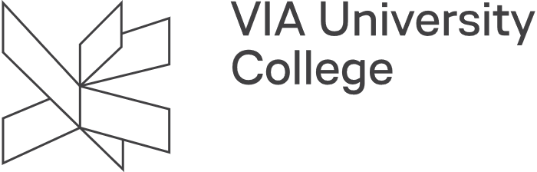

**Characters with spaces 13888**

**Software Engineering**

**Bachelor**

**20-12-2019**

Acknowledgement

Here we would like to thank to our supervisor Kasper Knop Rasmussen for his guidance and supervision during the project period. His feedbacks and support were extremely helpful, and we are very grateful for his extra hard work.

**Table of content**

Acknowledgement 2

Introduction 1

Group description 2

Project Initiation 2

Project Description 3

Project execution 3

Inception 5

Elaboration 5

Construction 5

Transition 5

Scrum 6

Personal reflections 7

Akos Faddi 7

Krzysztof Majcher 8

David Kabaly 9

References 10

**List of figures**

Figure 1 Trello's board GUI 3

Figure 2 AUP timetable 4

Introduction

Our project had a main focus on the SCRUM framework and feature-driven development. Daily meetings had been held to make sure about the efficient work within the team. Supervisor meetings were maintained weekly during the whole bachelor project process.

Each sprint had a one-week duration where we tried to achieve everything that was planned for the given Sprint. There were many points that were successfully completed but also some optional features that had to be put for the next sprint or skip them entirely.

During the project, every member was fully focused on the project with few problems like sickness or some emergency situations. In the beginning, there was some misunderstanding with the stakeholders who cancelled the project when it needed to be started but eventually, it has been started as an individual bachelor project.

Group description

The bachelor project group consists of 3 International members who had experience of working together since the middle of the education program, that means the teamwork and workflow was already familiar for each of the team members which provided a better result during the project.

Project Initiation

During the last semester, the team had its initiation phase. All the members agreed that we would like to find a company to work with and make a meaningful project.  
After some time we found a company called SimpelNem that was the company of our web developer teacher from the first semester.

They proposed an interesting project idea that the corporation wanted to work with us. The team has eventually accepted the project and started to work on it with not too much input from the stakeholder.

Unfortunately, at the beginning of the current semester, the company cancelled the project, so the team decided to start and work on the idea alone.

Project Description

During the initial phase of the project description, there were some problems between the members. The conflict was about how the system should be built and how the overall architecture should look like.

However, during the actual project description phase, most of the questionable product-related issues were cleared out and every member was happy with the result.

Project execution

As a main project management tool, we decided to use an online tool called “Trello”.

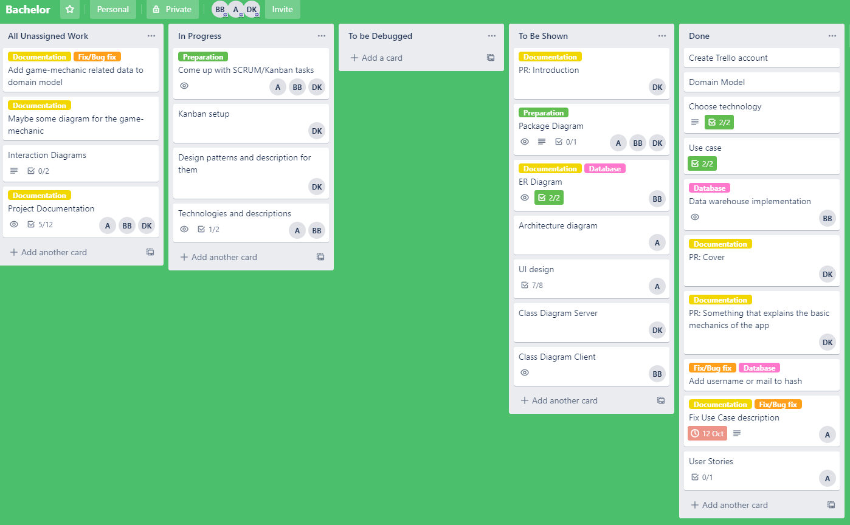

Figure 1 Trello's board GUI

Figure 1 Trello's board GUI shows Trello’s board GUI. Trello is a free project management tool. This tool visualizes the current project in the form of a board. On this board, developer team can organize tasks in the form of cards and store them. We decided to create five lists and store the tasks accordingly to their progress level, additionally in each card there is an option to add a check list and split more complicated tasks into smaller parts. Each card can be assigned to a specific team member who is responsible to fulfill those tasks.

To have a proper structure during the development we used Agile Unified Process.

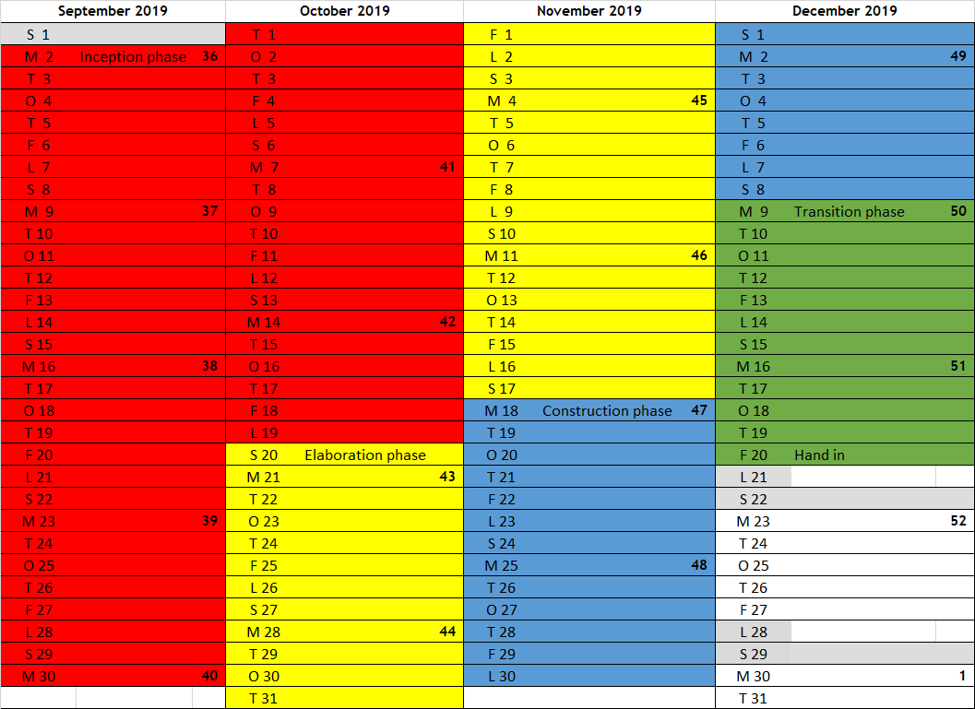

Figure 2 AUP timetable

Figure 2 AUP timetable visualize how each phases of Agile Unified Process were divided during the project period.

Inception

In this phase of the project the team must focus on analyzing what they want to work on and setting a time boundary. Understanding the given problem is the most important part of this phase. The goal of the Inception is to establish the case for the viability of the proposed system. (Scott, 2002)

Elaboration

In this phase of the project the focus is to design a system according to the results of the previous phase. In this phase UML is used to create initial design of the system like a package diagram. To see the package diagram please refer to the *Appendix D – Package Diagram* section. At the end of this phase a common and understandable vision of the system should be created. Also, the team should have planned the skeleton of the system already.

Construction

In this phase of the project the goal of the team is to implement the results of the previous phase. The team must go more into details and extend diagrams created in the Elaboration phase. A big challenge of the construction phase is to overcome technical difficulties that weren’t identified in previous phases. During this phase the developer team must make sure that they are following a common vision of the system.

Transition

In this phase of the project the focus is on documenting the results of the group work and to correct any defects or unidentified problems. Documenting and developing a project simultaneously will make documentation very difficult, because it would be hard to keep track of a constantly changing system but testing and fixing is necessary. Documentation is essential in reaching any project value. Not documented projects have a low chance of being used in the future and do not provide any research value.

Scrum

The Scrum framework was used during project development, with small changes. The daily scrum meetings haven’t been written down, as they were really short meetings, and sometimes we had them multiple times a day if we felt the need. We quickly realised that the product backlog does not contain all the tasks that we have to do, that’s why the product backlog had to be updated at the end of almost every sprint. The product backlog that is in *Appendix-H* is the latest version of it. The burndown chart has been updated based on this product backlog. All scrum related documentation can be found in *Appendix-H.*

**Scrum roles**

**Product owner:**

Product owner is responsible for providing consistent vision of the system to the team. His additional responsibility is to suggest priorities in product backlog. The product owner during the project was Akos Faddi.

**Scrum master:**

Scrum master is a person responsible for project management. His main responsibility is to make sure that team follows practices of the scrum methodology. In order to do that he is organizing daily scrum meetings to ask each developer team member following questions:

* What will you be doing today?
* What did you do yesterday?
* Do you need help with anything?

This way, the scrum master can keep track of the progress of the developer team and notice and solve challenges. The scrum master must make sure that the team is working on its full potential. Additional responsibility of the scrum master is to discuss with the product owner the current situation of the project to avoid misunderstandings. The scrum master during the project was David Kabaly.

**Developer team:**

Each member of the developer team has a personal responsibility to fulfil requirements of a given task and to not overestimate or underestimate own abilities and report to others any obstacle that appears during development. The developer team during this project was Akos Faddi, Krzysztof Majcher and David Kabaly.

Personal reflections

Akos Faddi

At the beginning of the project, the team had different opinions about what kind of project should we make. However, there was one thing that we all agreed on and that is to find a company that could provide an interesting project to work on. We all wanted to make sure that we will gain even more experience in real-world projects. After some time, I found a company called “SimpelNem” who wanted to develop an Android application that seemed interesting. Following some discussions, the team decided to make a partnership with the company, and we started to work on the project mostly on our own. The company, unfortunately, cancelled the project but they gave the chance to us to continue and work on it.

The beginning was hard since we were expecting to work with the stakeholders but then we had to make everything ourselves. Many discussions were made about the project but in the end, we could decide what we want to do.

In order to make sure the project stays on a strong foundation, many diagrams were made because of the suggestion of our supervisor. It helped a lot for imagining how the project will look like and what will be the details.

During the implementation phase, the team members had some problems working together on the project. However, after some discussion, we solved the problems in a way that is acceptable to everyone. Some technologies were hard to use but after some research, all of us were capable to use them but it took some time.

Personally, I was focusing on the implementation of the Client-side which was a challenging task. I used a lot of knowledge from my internship place, but many kinds of research had to be made because of some lack of knowledge. In the end, many of the planned things were finished but some features that we wanted to implement were not done because of the lack of time.

In my opinion, this project was hard to make and took a lot of time and dedication from the team members. However, in the end, I think we made a valuable system with good features that are enjoyable.

Krzysztof Majcher

During the project period, I had great pleasure working on this application. For me as a person that chooses the database specialization, this project was a great opportunity to reinforce my skills and gain a motivation to step out from my comfort zone and learn something new. Especially for this project I learned android development and I’m very happy that I can straight away use my newly acquired skills in something constructive. Working and learning at the same time is challenging but also very satisfying.

The cooperation between group members went smoothly and without any accidents. Any appearing conflicts were solved by constructive and respectful discussion. If any of the sides didn’t achieve a meaningful advantage regarding a problem that was solved by flipping a coin. The work was divided equally and according to personal preferences. During work splitting, we put an extra focus to make sure that everyone can work on something constructive and have something to do all the time. This approach ensured that no one felt excluded in the project and the group could work on Its full effectiveness. Those practices were applied to all phases of the project, for that reason this project can truly be called a group work.

If I would have to do the project again, I would change some of the choices of technology, mainly for the pure curiosity of how they would perform in the same project and personal need to learn something new. I would like to try out something that would allow me to develop cross-platform and add more UI fireworks. Something like for example unity that was originally discarded due to lower performance and the fact that we won’t use most of its functionalities of a game engine.

In this project, I especially like freedom of approach on given problem. Not only in choosing technologies and patterns but also in prioritizing system features. That adds additional research value to the project but also a responsibility. I strongly believe that due to the variety of technologies, patterns and solutions that were used during this project made a meaningful value.

David Kabaly

When we first started to look for a Bachelor project, all of us wanted to work with a company, so we could have a concrete set of requirements and an actual product owner. We managed to contact a company and came to an agreement to develop their product, but later they abandoned it, so we had to define the requirements ourselves.

At the start, we had a difficult time defining what kind of application we are going to make, how we are going to make it. It felt a little bit like we were stuck in place because we had different ideas and would have liked to approach the project from a different angle. This part was extremely necessary, so all members would be on the same page.

Later, when we worked on the design it was easier to separate things, for example, Krzysztof and Akos were responsible for the client, while I was planning for the server. Thinking back, I think this phase took a little bit longer than it should have, but I felt ready to get into the implementation phase.

During that phase, it was challenging, because I decided to look into some technologies that I haven’t been familiar with, but it looked like the development process could have been made simpler, so I decided to use these technologies. As an addition, I thought that would be more fun to work with something other than plain java.

These technologies took a lot of time to get familiar with, in the early and middle phases of implementation I wasted a lot of time figuring how some of the features of these technologies work. By the end, it was simple to use them to whatever I needed them and made me happy that I “conquered” a technology.

In the end, we had to stop the implementation to have enough time to finish the documentation. We were ahead of schedule, but at the very end, little things always came up and I felt a little demoralized that we could not close the project report and say that we don’t need to touch it again.

As a conclusion, it was challenging, but I feel accomplished and I could imagine continuing this project even after graduation.

References

Scott, K., 2002. *The unified process explained*. Addison-Wesley.